

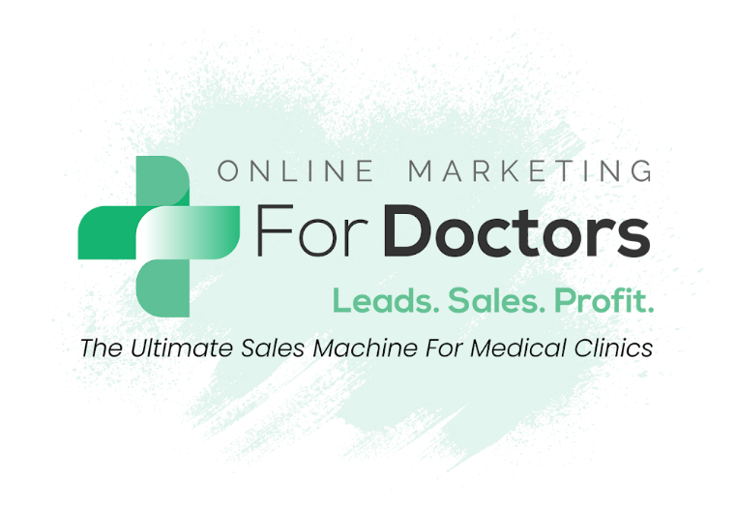

Brand Questionnaire

For

Adore Life

https://adore.life/



About Your Brand & Clinic
This form helps us understand your clinic, your brand, and your patients so we can structure website content effectively.

Clinic & Primary Contact Information
- What is the name(s) and email address of the primary person involved in the day-to-day communication and who will be our go-to for all campaign questions, updates, etc?

Primary Contact(s)
Person 1
Name
Email Address
Role
Phone Number
Person 2
Name
Email Address
Role
Phone Number

Secondary Contact(s)
Person 3
Name
Email Address
Role
Phone Number
Person 4
Name
Email Address
Role
Phone Number

- What is the full, legal name of your company?

- What is the complete address for your main clinic?

- What is your Doctor Registration Number?

- When did your clinic officially open?

Clinic and Patient Value

- What problems do you help solve for your patients/clients?

Rhinoplasty - Aesthetic and Medical reasons

- How does your patient/client feel after you solve their problem?

Aesthetic

Medical

- Was there any unexpected value added to your patient/client's life when they received treatment or purchased your services?

- Can you describe the typical patient journey from first contact to post-treatment follow-up?

Services & Procedures

- What are the main procedures or services you want to promote on the website? Please provide a list of relevant keywords.

Rhinoplasty -

Facelift -

- Could you please provide pricing information for these procedures/services? (Starting prices are fine if there are multiple options.)

Rhinoplasty - from £9,000

Face / Neck Lift Surgery - from £16,750

- What has been your most popular product/service historically?

- Are there any standout patient success stories or transformations you would like to highlight? (Before & after, with permission)

- What are the most common questions or concerns patients have before visiting your clinic, and how do you address them?

Team & Expertise

- Can you provide more information about the lead doctor/owner of the clinic? For example, share your story, education, qualifications, and experiences. Highlight major achievements you are proud of, such as working, studying, or training in multiple countries, being mentored by high-profile surgeons, or any significant milestones that showcase your expertise and leadership. Please also highlight any additional training, certifications, or specialised skills you’ve completed that demonstrate your dedication and expertise.

I began my plastic surgery training in the UK in 2001, completing higher surgical training in Cambridge before achieving my Certificate of Completion of Training from the GMC in 2012. Driven by an interest in head & neck and breast surgery, I went on to complete fellowship training at St Andrews Hospital in Chelmsford — the UK's largest plastic surgery unit — and the Royal Marsden Hospital in London.
Alongside my clinical work, I hold a PhD and have published in peer-reviewed journals, contributed book chapters, presented internationally, and peer-reviewed for leading medical journals. Since 2012 I have worked as a consultant in Cambridgeshire, holding NHS leadership roles including Clinical Lead for Plastic Surgery and Surgical Specialty Lead for the Eastern Region of the NIHR.
I am on the GMC's specialist register for plastic surgery and the Royal College of Surgeons' register as a Certified Cosmetic Surgeon. I am a Fellow of the Royal College of Surgeons in Edinburgh (FRCS Plast), a Fellow of the European Board of Plastic, Reconstructive and Aesthetic Surgeons (FEBOPRAS), a member of BAAPS and BAPRAS, and an international member of the American Society of Plastic Surgeons (ASPS).

- Can you provide short bios for every staff member, along with images via Google Drive?

- What organisations, associations, or professional bodies are you or your team part of?

Organisations, associations & professional bodies:
- General Medical Council (GMC) — on the specialist register for plastic surgery
- Royal College of Surgeons of Edinburgh — Fellow, FRCS (Plast)
- Royal College of Surgeons — listed on the Certified Cosmetic Surgeons register
- European Board of Plastic, Reconstructive and Aesthetic Surgeons — Fellow (FEBOPRAS)
- British Association of Aesthetic Plastic Surgeons (BAAPS) — member
- British Association of Plastic, Reconstructive and Aesthetic Surgeons (BAPRAS) — member
- American Society of Plastic Surgeons (ASPS) — international member
- National Institute for Health Research (NIHR) — served as Surgical Specialty Lead for the Eastern Region
All operating facilities and services are also registered with the Care Quality Commission (CQC).

- Could you share what drives your passion for your profession? What inspired you to pursue the work you do today, and what do you enjoy most about providing your treatments and services? We’d also love to highlight the unique value you offer patients as part of their care — for example, added benefits like complimentary scans, inclusive follow-up appointments, secondary consultations at no extra cost, or even the opportunity for prospective patients to speak with previous patients about their experience with you and your clinic.

Clinic Advantages & Brand Identity

- What are the top 5 selling points that truly differentiate your clinic from others in your field? For example, do you offer added value such as complimentary follow-up appointments, a second consultation at no extra cost, flexible or interest-free payment options, highly personalised treatment plans, cutting-edge technology or equipment (please specify), extended opening hours, faster appointment availability, or a dedicated patient care coordinator?

- If your clinic had a specific “identity” or “personality,” how would you describe it? (e.g., professional, approachable, luxurious, innovative)

- What is your preferred branding direction for this project: maintain your existing brand identity and colour palette, refresh your current branding, or undertake a complete rebrand?

- Are there specific values or messages you want every patient to take away from your clinic?

Patient Feedback

- When you’ve asked past patients — or even prospective patients who chose not to go ahead — for feedback, what do they say they appreciate most about your clinic, and what areas do they feel could be improved?

- Have there been any unforeseen benefits your patients experienced that you didn’t anticipate?

Technology, Facilities & Recognition

- What advanced technology, equipment, or techniques does your clinic use that sets you apart?

- Are there any recent upgrades, innovations, or improvements in your clinic that patients should know about?

- Has your clinic or team been featured in media, awards, or publications?

- Are there any testimonials from patients, influencers, or partners that you would like to highlight?

Media & Visuals

- Can you provide photos and videos of:
- Main doctors
- Staff
- Office/shop (indoor and outdoor)
- Before/after images
- Other images & videos you would like to use for the new website
You can share your files via Google Drive: Client Asset Uploads

- Can you share professional certificates, accreditations, memberships, and awards, if any?

Locations & Target Market

- What are your target locations? (Please include all suburbs, if any.)

- How many locations do you currently have? Do you have Google My Business listings set up for these locations?

- Describe your ideal patient/client. Include as much detail as possible: gender, age, location, interests, and specific problems or pain points.

Website Features & Integration

- Please list all the features you want to have on the new website (e.g., contact form, online booking, ebook download, quiz, live chat, etc.)

- How would you like your website to be hosted: OMD-hosted and managed, or deployed to your own hosting environment?

- If you have any appointment booking software, email marketing, or SMS marketing software, please share the login details with us.

Competitors & Market

- Who are your 5 biggest competitors?

- Who is the biggest brand in your niche, and what is their flagship product/service?

Community, Content & Milestones

- Is your clinic involved in any charities or nonprofits? If yes, please list it here.

- Do you have any case studies, before/after examples, eBooks, webinars, or other content offers? If yes, please save on our shared Google Drive.

- Have there been any notable milestones you can share with us? This includes new product/service launches, recognition in the media, or any achievements you’re proud of. If yes, please list it here.

Performance & Conversion Tracking

- To help us establish accurate baseline tracking and measure campaign performance effectively, could you please provide the booking numbers for your main procedures over the last 12 months (or at minimum, the last 6 months)?
Where possible, we would also appreciate details on the source of these bookings (e.g. Google Ads, Organic Search, Social Media, Referrals, etc.).
b) In addition, please share the number of enquiries and consultations for these procedures so we can better understand your conversion rates at each stage of the patient journey and accurately track future campaign ROI and performance improvements.
Disclaimer: Please note that if consultation and procedure booking data is not provided after the campaign commences, we will be unable to report accurately on ROI and revenue performance from the campaign results. In this case, campaign reporting will be based on lead volume only.

About Your PPC

- What is your Google ads campaign specific goal? (example: 150 new leads in 3 months, 50 conversions a month, ideal cost per lead, cost per consultation, cost per procedure booking).

- Do you have any additional landing pages aside from your main site?

- Are you aware of any keywords related to your services that draw inpatients/clients?

- Are there any keywords we should avoid in our campaigns? (Negative Keywords)

- How soon do you follow the leads?

- How many times do you follow a potential lead until it is converted to a client/patient?

- What methods have you been using to follow a lead?

- Have you got anyone in charge to follow and convert the leads?

About Your Meta Business

- Do you have a Facebook/Instagram/Meta Business account? If yes, can you share the Admin access to our Business ID: 1499350623462442

- Do you currently have full control access to your Meta Business Portfolio (Business Manager/Meta Business Suite)? ☐ Yes / ☐ No
If yes, please provide the name of the owner and the email address associated with the primary admin access.

- Who is the main person responsible for managing your Meta Business assets?
Please provide name, role, and email address.

- Is there anyone else on your team who requires access (Admin, Employee, Analyst)? If yes, list their roles and email addresses.

